**Smart water meter data analyzed to solve water issues**



**BTech/II Year CSE/III Semester**

**19CSE202/Database Management Systems**

**Case Study Review -1**

|  |  |
| --- | --- |
| Rollno | Name |
| CB.EN.U4CSE21062 | **Tangudu Harsha Vardhan** |
| CB.EN.U4CSE21034 | **Manthini Meher Vardhan** |
| CB.EN.U4CSE21040 | **Nerella Geetha Krishna** |
| CB.EN.U4CSE21036 | **Mittapalli Rohith** |

**Department of Computer Science and Engineering**

**Amrita School of Computing, Coimbatore**

**Amrita Vishwa Vidyapeetham**

**2022 -2023 Odd Semester**

Table of Contents

**Title Page number**

Chapter 1 2

Introduction 3

Abstract 4

Chapter 2 Logical Database Design ER Diagram 5

Entities 6

Attributes 6

Relationships 7

ER Diagram 8

Chapter 3 ER to Relational Schema Mapping 9

Chapter 4 User Interface Screens 6

# Chapter 1

# Introduction :

Smart metering improves the operations while reducing the consumption per capita, wastage, leakages, and operational and maintenance costs. Major benefits include;

* Monitor the flow, distribution, and consumption of water
* Improve access to clean and safe water
* Enable real-time or frequent access to water consumption information and billing
* Reduce manual water meter reading and cost
* Improve leak and fraud detection
* increases data collection accuracy

Although there are many benefits and opportunities the smart metering delivers, the adoption is very slow due to high costs, technology limitations, regulatory frameworks, and others. Major drawbacks include;

* High deployment and maintenance costs
* Lack of sufficient infrastructure to support smart metering
* Lack of skills
* Interoperability issues
* Weak communication signals in some locations
* Power cabling challenges in confined and remote locations

# Abstract:

**Smart water meter** is an innovative device that measures, analyses, and communicates water-related data. Detecting inappropriate consumption of water.

**What are the loses of Traditional water meter:**

* Traditional water meters allowed water utilities to record the water consumed by a household or an industry and bill them accordingly.
* Incapable to fulfil the sustainable development policies made to reduce water wastage and contamination.
* This is due to unidentified losses in the form of water pipe leakages, frauds, and defective meters**.**

**Few uses and examples of Smart water meter:**

* Allowing remote location monitoring and infrastructure maintenance through leak detection.
* Enable automatic billing and customer management.
* Due to their battery-powered nature, smart water meters play an important role in system configuration.
* automatic sprinkler system can be used in sports fields and farms to keep the grass/crops fresh with the minimum usage of water.

**UI:**

HTML, CSS, JAVASCRIPT (for front-end webpage)

**Database:**

Live SQL server & pgAdmin 4

**Analysis that will be done on the data:**

* Types of smart water meter and their specifications
* Data related to subscriber like Meter ID, Subscriber ID, capacity of meter, mobile number, type of residence, Address/locality.

# Chapter 2 Logical Database Design ER Diagram

## Entities

* City
* Area
* Communities
* Crosses
* Appartment
* Individual houses
* Member
* water_meter
* location_of_meter
* server
* server_member
* Billing
* complaint

## Attributes

* City (city_boundaries,City_code,city_population,city_name)
* complaint(complaint_id(pk),complaint_reason)
* server(server_number(pk),server_code(fk),server_location,server_connections,server_type,server_capacity)
* server_member(employee_id(fk),address,name,member_phno)
* billng(bill_id(pk),reading_id(fk),clint_id(fk),rate,collector)
* water_meter(meter_id(pk),meter_capacity,emplayee_id(fk))
* location_of_meter(meter_id(fk),reading,area)
* Area(Area_name,Area_code,Area_population,area type(rural,urban))
* Communities(Population, Community_code,Name, Address,communitytype(buildings, individual house)
* Crosses(Crosses_type,Crosses_code,Crosses_capacity,Crosses_population)
* Appartment(Appartment _size, Appartment_code, Appartment population,Apptmembers (workers,owners)
* Individual houses(House capacity,house_meter,owner phoneno,house_no,ownername)
* Member(Member I’d,name, member serial)

## Relationships

* City has Area
* Area has communities
* Communities has crosses
* Crosses has Appartments
* Appartments has individual houses
* Individual houses has members
* Member complaints complaint
* City,Area,Community,Crosses,Appartments and Individual_houses has Water_Meter
* Water meter has meter_location
* Water meter controlled by server
* Server have server_members
* Server manages complaints

# ER Diagram

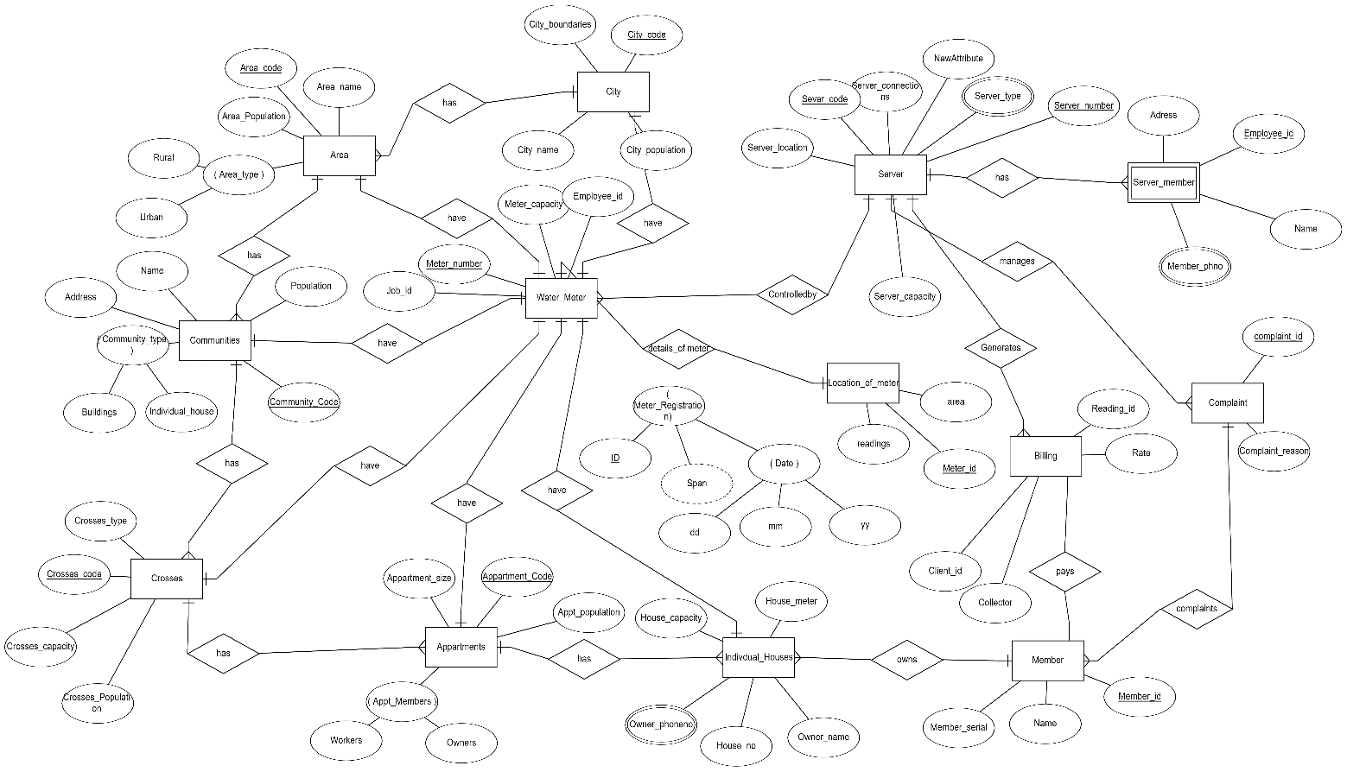

# Chapter 3

# ER to Relational Schema Mapping

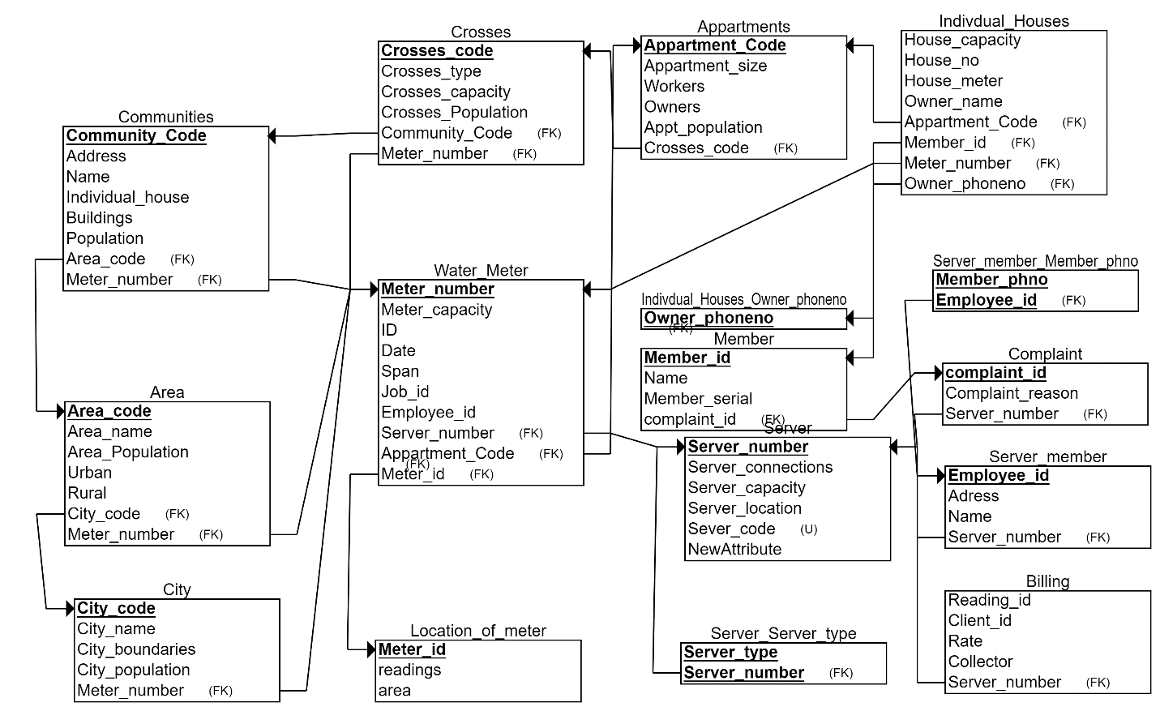

# Chapter 4 User Interface Screens

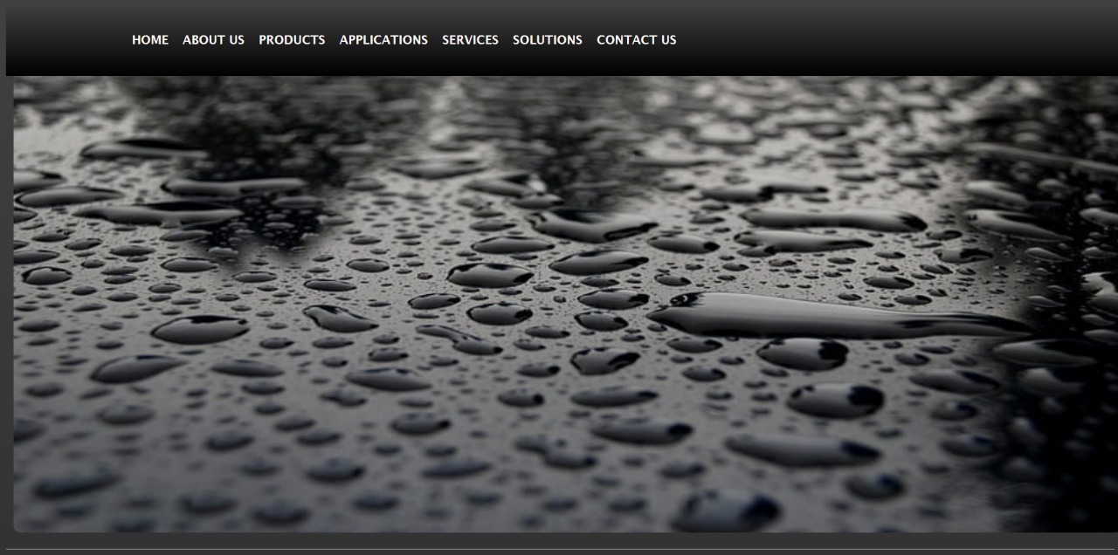

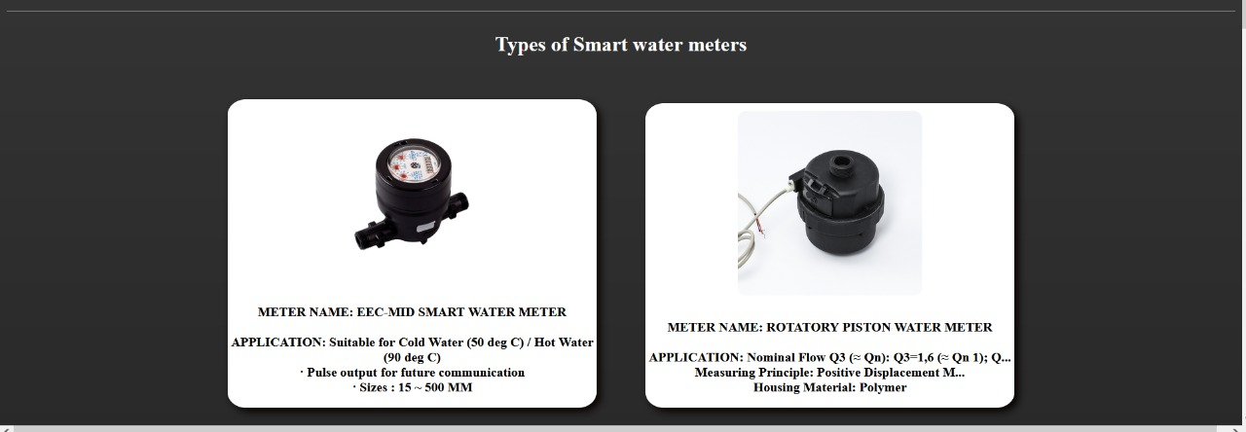

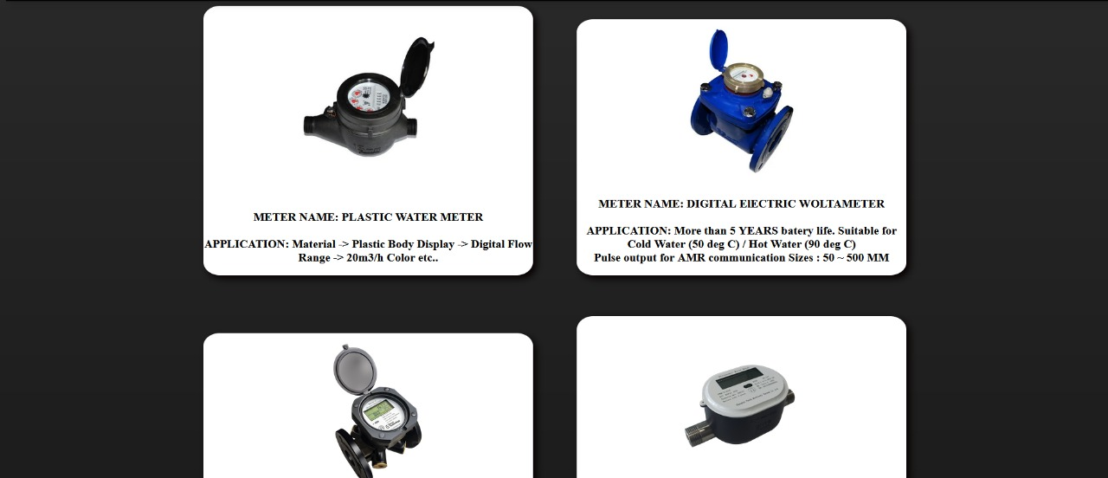

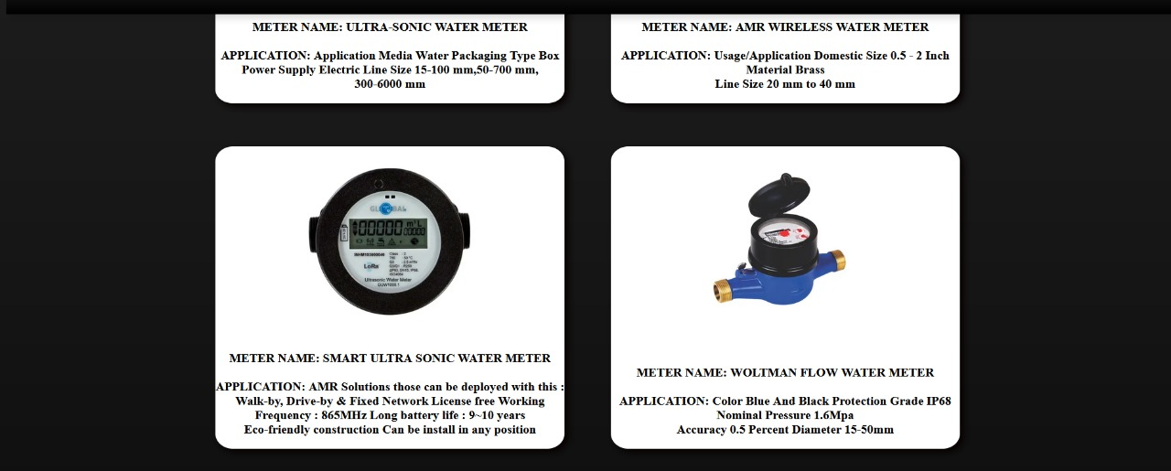

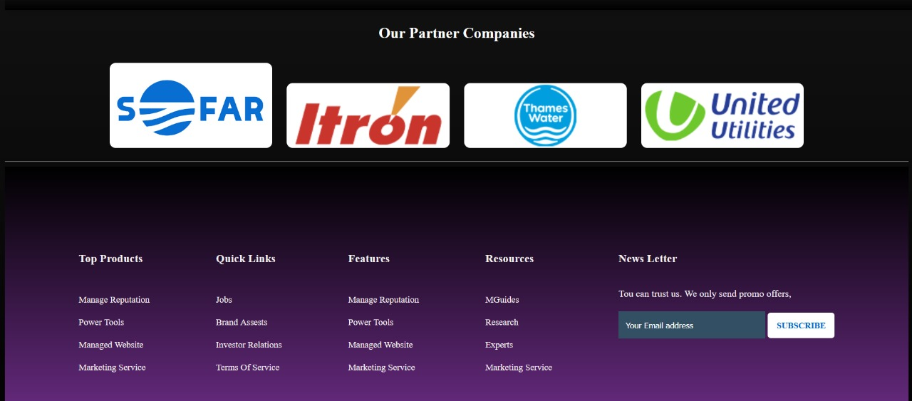

**REFERENCES:**

[**https://unsplash.com/s/photos/water-meter**](https://unsplash.com/s/photos/water-meter)

[**https://www.peltekindia.in/smart-water-meter-C-37.html**](https://www.peltekindia.in/smart-water-meter-C-37.html)

[**https://www.wegot.in/blog/understanding-the-different-types-of-water-meters/**](https://www.wegot.in/blog/understanding-the-different-types-of-water-meters/)

[**https://www.indiamart.com/proddetail/amr-wireless-water-meter-22814774062.html**](https://www.indiamart.com/proddetail/amr-wireless-water-meter-22814774062.html)